Dashboard Creation
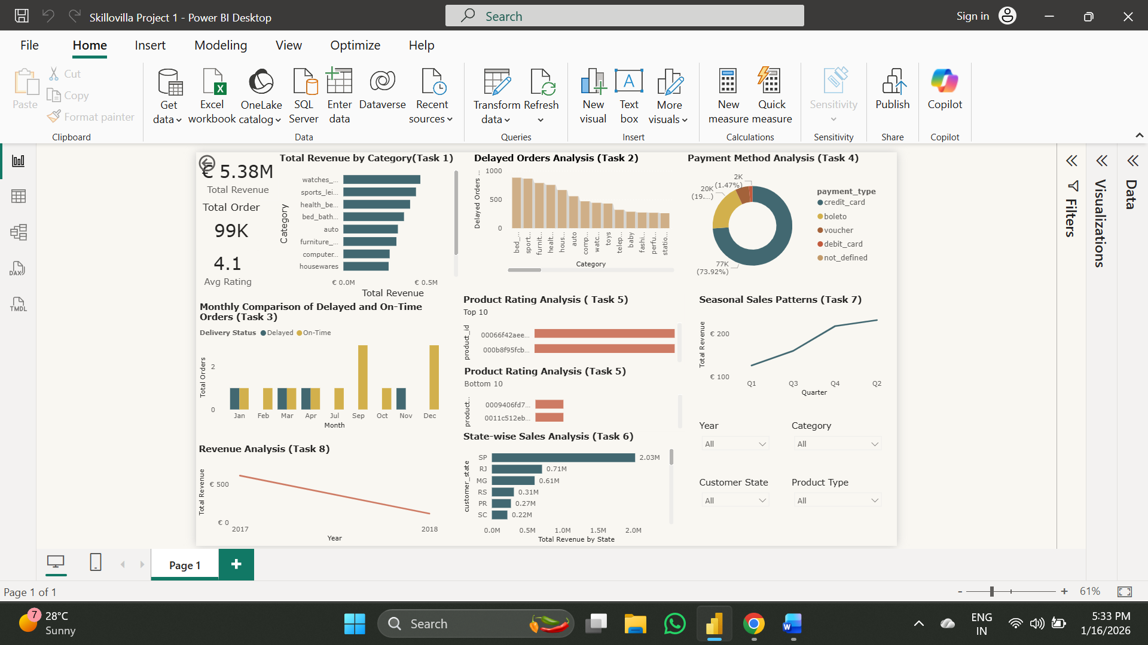

Creating Cart (Top left 3 charts)
- Total Revenue:
- Go to report view (select card view)
- Putting a measure “Total Revenue” in the fields
- Callout Value on the filter pane is Million, and the Decimal value 2
- Total Order:
- Select card Icon
- Putting a measure “Total Orders” in the fields
- Adding a title “Total Orders”
- Callout value “Thousands” and Decimal no 0
- Average Rating:
- New Card
- Putting the “Avg Rating” measure in the field
- Format Pane decimal no. 1, Adding the Title “Avg Rating”
Task to Accomplish:
Task 1
Top Categories by Total Price:
* Identify and visually represent the top 10 product categories by total sales.
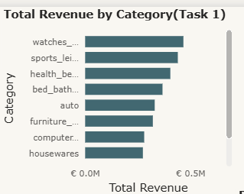
- Select Bar Chart
- Y Axis = Category, X Axis = Total Revenue.
- Filter Pane, go to category, then Top N, where N = 10; by value Total Revenue.
- Sort the total revenue in descending order.
Task 2
Delayed Orders Analysis:
* Determine the number of delayed orders in each category. An order is considered delayed if the actual delivery date is later than the estimated delivery date.
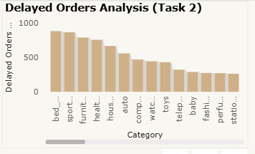
- Select column Chart
- Y Axis = Delayed Orders (by Category), X Axis = Category.
- Filter Pane, go to Category, then Basic Filtering, and unselect the Blank.
- Sort the Delayed Orders (by category) in descending order.
Task 3
Monthly Comparison of Delayed and On-Time Orders:
* Create a dynamic visual that compares the number of delayed orders to the number of orders received earlier for each month. Utilize the drill-through cross-report feature to provide a detailed analysis of late and on-time deliveries.
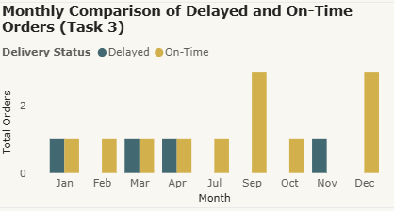
- Select Clustered Column Chart.
- X Axis = Month, Y Axis = Total Orders, Legends = Delivery Status.
- Go to the Filter Pane, then Month, then unselect the Blank from the dropdown.
Task 4
Method Analysis:
* Analyze the most frequently used payment methods by customers using a visually appealing representation, such as a pie chart or other suitable visuals.
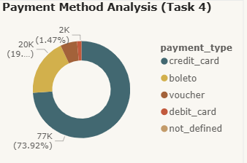
- Select the Donut Chart
- Legends = Payment_type, Values = Total Payment
Task 5
Product Rating Analysis:
* Determine the top 10 highest-rated products and the bottom 10 lowest-rated products using a bar or column chart.
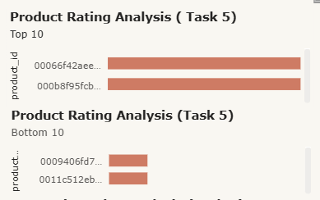
- Select the Bar Chart for Top 10 and Bottom 10.
- Y Axis = product_id, X Axis = Avg rating by product (for both Top & Bottom)
- Go to Format Visual, then X Axis range, Min = 0 and Max = 5 (for both Top & Bottom)
- For Top 10, go to the filter pane, then click on product_id, then click on Top N, where N = 10.
- For Bottom 10, go to the filter pane, then click on product_id, then click on Bottom N, where N = 10.

Task 6
State-wise Sales Analysis:
* Identify and visually represent states with high and low sales, providing a clear understanding of regional sales performance.
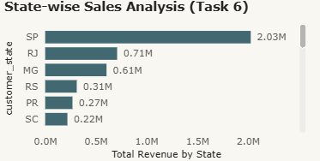
- Select a Bar Chart.
- Y Axis = Customer_state, X Axis = Total Revenue by state.
- Go to the filter pane, then Customer_ state, then Top N, where N = 10.
- Total Revenue is sorted in Descending.
Task 7
Seasonal Sales Patterns:
* Investigate and visualize any seasonal patterns (Quarterly) or trends in sales data over the course of the year.
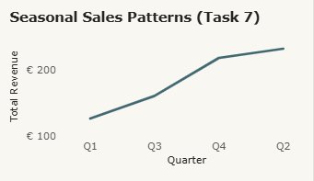
- Select a Line Chart.
- X Axis = Quarter, Y Axis = Total Revenue.
- Go to the Filter Pane, then Quarter, then unselect the Blank.
- Sort Total Revenue in Ascending.

Task 8
Revenue Analysis:
* Determine the total revenue generated by ShopNest Store and analyze how it changes over time (Yearly). Represent this information through suitable visuals to highlight trends and patterns.
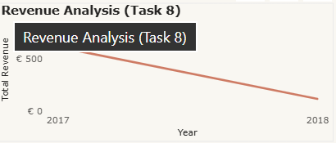
- Select a line chart
- X Axis = Year, Y Axis = Total Revenue.

Mandatory Changes in all 8 charts:
- Go to the Filter Pane
- Then, go to Visual OFF the Gridlines
- Then, go to General ON the Title and give a suitable Heading ( I used the Task Heading [Task Title]).
The Slicers:
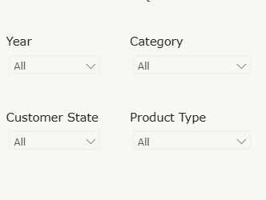
- Year (Date_Table)
- Category (Product_Category_Translation)
- Customer State (Nexeusgoods_customer_dataset)
- Product Type (Nexeusgoods_order_payments_dataset)
Common steps for all Slicers:
- Select the Slicer
- Drag the Table Column
- Go to format the visual, then Slicer settings, and then select Dropdown.

